**Hibernate-**

Hibernate frameworks is mediator through which java application is communicated with database. It is open source frameworks. It is Object Relational Mapping (ORM) tool.

Hibernate is a Java framework that simplifies the development of Java application to interact with the database. Hibernate implements the specifications of JPA (Java Persistence API) for data persistence.

ORM Tool -

An ORM tool simplifies the data creation, data manipulation and data access. It is a programming technique that maps the object to the data stored in the database.

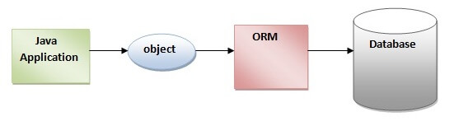

*****

**Why?**

* In JDBC, if we open a database connection we need to write in try, and if any exceptions occurred catch block will takers about it, and finally used to close the connections.
* We must close the connection, or we may get a chance to get connections error message.
* Actually if we didn’t close the connection in the finally block, then jdbc doesn’t responsible to close that connection.
* In JDBC we need to write Sql commands in various places, after the program has created if the table structure is modified then the JDBC program doesn’t work, again we need to modify and compile and re-deploy required, which is tedious.
* To overcome above drawbacks we should go for Hibernate framework.

**Advantages of Hibernate-**

1. It is open source frameworks.
2. Faster performance-

It uses cache concept hence the performance is fast.

1. Database independent query-

It generates the database independent query.

1. Automatic table creation-

It has facility to create the database tables automatically. There is no need to create the database tables manually.

1. Simplifies the complex join-

It is easy to fetch the data from multiple tables in hibernate framework.

**Hibernate Architecture-**

Hibernate architecture includes the many persistent objects such as session, session factory, transection factory, connection factory and transection etc. there are different types of layer in hibernate such as

* Java application layer
* Hibernate frameworks layer
* Database layer

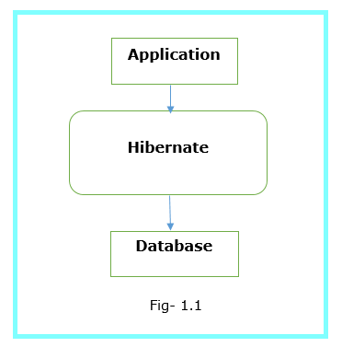

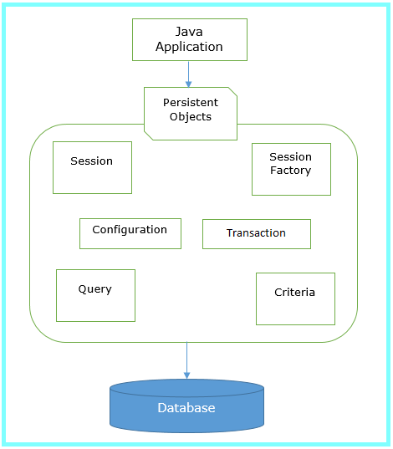

**Key points of Hibernate architecture-**

1. SessionFactory-

* It is factory of session.
* It holds the second level cache.
* SessionFactory interface provides the factory method to get the object of session.

1. Session-

* It is the factory of transection, query and criteria.
* It holds first level cache.
* It provides the method to insert, update and delete the objects.
* It also provides the factory method for transection, query and criteria, etc.

1. Transection-

It is the interface that provides the method for transection management.

1. Connection provider-

It is the factory of JDBC connection. Which driver is used to connect to database.

1. TransectionFactory-

It is the factory of transection.

Note- Every hibernate program we must need two files for mapping.

**First Hibernate Application**

Hibernate operation-Insert data into table.

1. Package structure for hibernate
2. Create java project
3. Add jar for hibernate
4. Create the persistent class or POJO class
5. Create the mapping file for persistent class
6. Create configuration file
7. Create the class that store persistent objects
8. Run application.
9. **Package structure for hibernate**

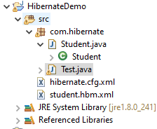

1. **Create the java project**

File menu->New->Project->Java Project->Specify Project name->next->finish.

1. **Add Jar files**

Right click on your project->build Path->Configure build path->Libraries->Add External Jar->Go to location where store the jar-> Select All jar-> click on open button->Apply and close button.

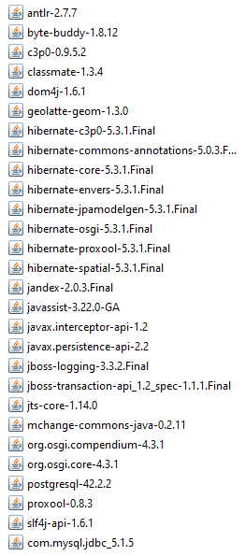

1. **Student.java (POJO class)**

**package** com.hibernate;

**public** **class** Student {

**private** **int** id;

**private** String firstName;

**private** String lastName;

**public** **int** getId() {

**return** id;

}

**public** **void** setId(**int** id) {

**this**.id = id;

}

**public** String getFirstName() {

**return** firstName;

}

**public** **void** setFirstName(String firstName) {

**this**.firstName = firstName;

}

**public** String getLastName() {

**return** lastName;

}

**public** **void** setLastName(String lastName) {

**this**.lastName = lastName;

}

}

Note-Hibernate mapping file is used by hibernate framework to get the information about the mapping of a POJO class and a database table.

1. **student.hbm.xml**

<?xml version=*"1.0"* encoding=*"UTF-8"*?>

<!DOCTYPE hibernate-mapping PUBLIC

"-//Hibernate/Hibernate Mapping DTD//EN"

"http://www.hibernate.org/dtd/hibernate-mapping-3.0.dtd">

<hibernate-mapping>

<class name=*"com.hibernate.Student"* table=*"emp"*>

<id name=*"id"*>

<generator class=*"identity"*/>

</id>

<property name=*"firstName"* column=*"first"*/>

<property name=*"lastName"*/>

</class>

</hibernate-mapping>

Note- if we don’t specify column tag then it will take property name as table column name into database. If we specify column tag then it will take that as column name into database.

Element of mapping file-

**Hibernate-mapping**: It is the root element.

**Class**: It defines the mapping of a POJO class to a database table.

**Id**: It defines the unique key attribute or primary key of the table.

**Generator**: It is the sub element of the id element. It is used to automatically generate the id.

**Property**: It is used to define the mapping of a POJO class property to database table column

1. **hibernate.cfg.xml**

<?xml version=*"1.0"* encoding=*"UTF-8"*?>

<!DOCTYPE hibernate-configuration SYSTEM

"classpath://org/hibernate/hibernate-configuration-3.0.dtd">

<hibernate-configuration>

<session-factory>

<property name=*"hibernate.connection.driver_class"*>com.mysql.jdbc.Driver</property>

<property name=*"hibernate.connection.url"*>jdbc:mysql://localhost:3306/test</property>

<property name=*"hibernate.connection.username"*>root</property>

<property name=*"hibernate.connection.password"*>root</property>

<property name=*"hibernate.dialect"*>org.hibernate.dialect.MySQL57Dialect</property>

<property name=*"hbm2ddl.auto"*>create</property>

<property name=*"show_sql"*>true</property>

<mapping resource=*"student.hbm.xml"*></mapping>

</session-factory>

</hibernate-configuration>

1. **Test.java**

**package** com.hibernate;

**import** org.hibernate.Session;

**import** org.hibernate.SessionFactory;

**import** org.hibernate.Transaction;

**import** org.hibernate.cfg.Configuration;

**public** **class** Test {

**public** **static** **void** main(String[] args) {

// step-1

System.***out***.println("line 1");

Configuration configuration = **new** Configuration(); // creating configuration object

System.***out***.println("line 2");

configuration.configure("hibernate.cfg.xml"); // this method is used to load cfg file

// step-2

System.***out***.println("line 3");

SessionFactory sessionFactory = configuration.buildSessionFactory();

// step-3

Session session = sessionFactory.openSession();

// step-4

Transaction transaction = session.beginTransaction();

// insert data into database

Student student = **new** Student();

// how to set the value into object student

// student.setId(10);

student.setFirstName("laxman");

student.setLastName("pawar");

session.save(student);

session.close();

System.***out***.println("Record saved successfully...");

}

}

**Output-**

